# Executive Summary

eComX is a blockchain protocol, run by eComX.org, that enables highly efficient eCommerce without intermediaries and at a substantially reduced cost.

eComX.org exists as a decentralized autonomous organization to solve the issue of inter-operability between existing centralized eCommerce infrastructures and eComX and among a number of blockchains and eComX. Another problem being solved, is the issue of scalability to which we believe eComX parallel computing approach through eComX optimized blockchain is the answer.

The solution is to build a new eCommerce model based on cooperation and trust. Not until the birth of blockchain as a technology of trust, the absolute cooperation among all of the beneficiaries became possible. Not only blockchain eliminates the issue of having a centralized intermediary to all transactions, but also it makes the problem of trustful cooperation programable, totally independent, and free of human biases.

There are many gears that makes eCommerce move, and at this time, too many of them are based on centralized systems, processes, and databases. It is clear that eCommerce needs to start moving these processes, systems, and datasets onto a blockchain. The eComX wrapper/transport utility token has been designed to facilitate the movement of these off-chain objects into the eComX blockchain by encapsulating the objects original data structure and mapping their values, data, and states needed for smart contracts, in the blockchain, to perform computational instructions on them.

For Example, the Internet of Things (IoT) represents new possibilities, however, interoperability and scalability remain major problems. Another trend worth looking at is at how businesses are using blockchain to enhance old methods and internal processes.

eComX represents a paradigm shift to eCommerce. As a transformation movement, eComX.org is the infrastructure and the eComX blockchain is the vehicle. eComX.org delivers an infrastructure of trust where all parties cooperate by building and sharing knowledge, processes, and software with other members. As a DAO for example, eComX.org is run by committees voted into office by eComX members, partners, and founders. Members can propose new projects or vote on existing ones, and partners can leverage eComX software library and resources to create new dapps and smart contracts to continue to make eComX better.

The end result is a platform capable of performing all the required functionality of traditional centralized eCommerce systems, but in a distributed and more efficient manner and at a substantially lower cost.

eComX utilizes a hybrid consensus mechanism allowing both POW and POS blocks, on distributed network nodes, to compete for the rewards and thus achieve maximum performance through parallel computing.

The eComX.world marketplace can handle crypto and fiat currencies alike. The technology can currently support 11 fiat and 4 crypto currencies, and it will continue to add additional ones, overtime.

eComX is implementing its own version of Turing-Complete Virtual Machine EVM, as opposed to using Ethereum’s VM for processing. The reason is that the Ethereum VM is quasi Turing-Complete due to the fact that execution is dependent on having enough gas reserved for nodes in the network. This is an inherent bottleneck that eComX is solving by having its own optimized VM.

We have completed the proof of concept, which includes the proof of concept for multiple events firing mechanisms for smart contracts, ECOMX transport and wrapper for objects across different blockchains and external objects, smart contracts as interfaces to global marketplaces, hybrid consensus and parallel computing.

eComX.org will use the DAO committees to continually foster participation in R&D and knowledge sharing by universities, user communities, investment communities, miner’s participant communities, marketplaces, logistics, fulfillment, payment gateways, etc.

eComX Corporation expects that it will complete the eComX token pre-sale campaign, eComX.org DAO registration. By the end of Q4 2018, we plan to release eComX.world cross-border marketplace and commence the operation of the eComX DAO. By the end of Q2 2019, we can expect the eComX main-net to go live, and by the end of 2019 we expect a target of more than $500 million USD in eCommerce related transactions processed in eComX.

By the end of 2020, eComX is targeting to have more than 2 billion USD in ecommerce related transactions running on the eComX blockchain network and by the end of 2021, as more major marketplaces around the world begin to use the eComX blockchain technology, eComX expects this estimate to increase by 10X.

To continue to remain independent (No control by anyone partner, marketplace, etc.), the eComX.org DAO will be transition from a quasi-independent organization, to a fully autonomous one. This is done to ensure that on its early stage of development, the organization maintains course ahead to deliver eComX as a public and open for all blockchain infrastructure for the crypto-ecommerce economy of the Internet of Values.

The eComX blockchain will be fueled by eComX tokens. They will be used to wrap and transport external objects in and out the eComX blockchain, as cross-chain interfaces, as GAS for our parallel computing nodes, and as rewards for future loyalty programs.

eComX Fund Raising

Since the creation of eComX, the organization has quietly been innovating and building its infrastructure. Amid all the doubts about blockchain technology, we have released a real-world crypto-ecommerce marketplace, our “Dapp Store Marketplace” is now open to the public, and our R&D work in inter-operability, the eComX blockchain, and parallel computing is moving ahead. We are preparing to be one of the first blockchain companies to make a splash on the real-world crypto-ecommerce economy and intend to lead by bringing real solutions to people and organizations around the world.

To continue the development, eComX needs to raise much needed capital in order to continue development.

eComX has met its Soft Cap using earlier investments from founders, friends, and family and has completed the project Structure, whitepaper, released the Fiat and Crypto Ecommerce Marketplace, [www.eComX.world](http://www.eComX.world), and it has released of the eComX “Dapp Store”, along with several other milestones.

eComX is now preparing to enter into a pre-sale and a three-phase eComX Token Sale through a TGE to seek further funding to complete the project, the distribution of both tokens and the “Use of Funds” are explained in the next several pages.

# eComX Token Distribution

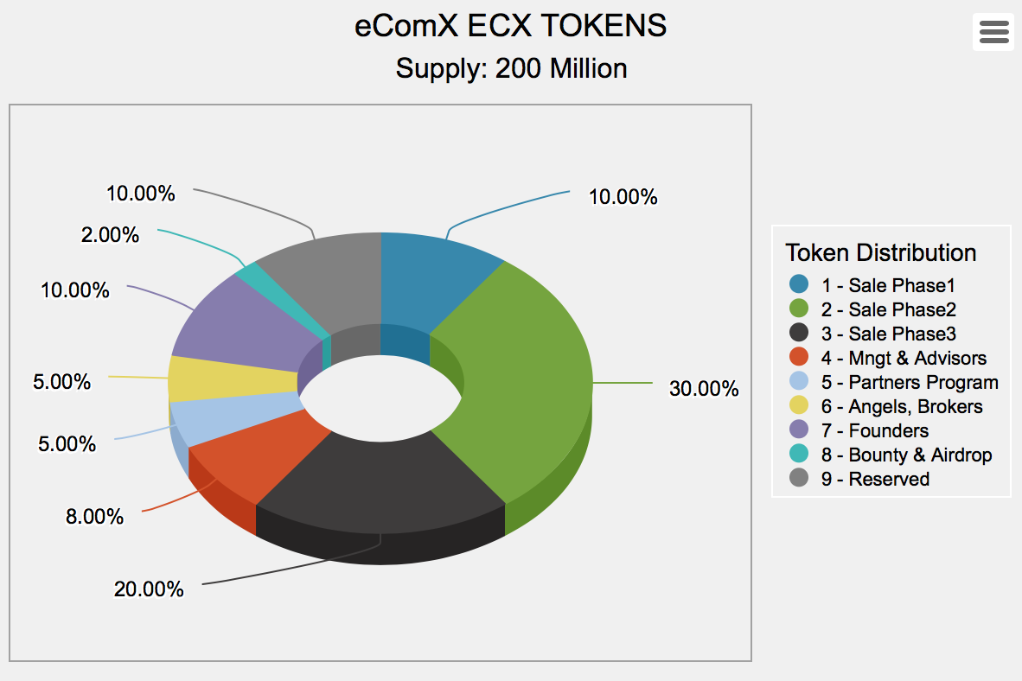

### TOKEN SALE - PHASE 1

10% (20,000,000) tokens are reserved for the eComX token sale phase 2. It will be subject to a minimum transaction of $25,000 for Accredited Investors and $50.00 for NON-US Individuals.

### TOKEN SALE - PHASE 2

30% (60,000,000) tokens are reserved for the eComX token sale phase 2. It will be subject to a minimum transaction of $25,000 for Accredited Investors and $50.00 for NON-US Individuals.

### TOKEN SALE - PHASE 3

20% (40,000,000) tokens are reserved for the eComX token sale phase 3. It will be subject to a minimum transaction of $25,000 for Accredited Investors and $50.00 for NON-US Individuals.

### MANAGEMENT AND ADVISORS RESERVES

8% (16,000,000) of the eComX token supply will be distributed to various advisory firms and individual advisors and management team members, who have helped with their inputs, expertise, and the conceptualization and implementation of the eComX platform. These tokens will be dispersed based on a 16-month vesting schedule with 1 million tokens released every month and divided equally by the number of Advisors and Senior Managers listed. The distribution will start 1 month after the private and public sale ends.

### PARTNERS PROGRAM

5% (10,000,000) of the eComX token supply will be reserved to develop eComX Partners Program to include major marketplaces, shipping, logistics, etc.

### ANGELS & BROKERS (SPONSORS’ PROGRAM)

5% (10,000,000) of the eComX token supply will be reserved to develop a community of accredited angel investors, early adopters, and brokers/agents critical for the funding needed to fully develop the project.

### BOUNTY and AIRDROP RESERVES

ecomX will set aside 2% (4,000,000) of the token supply for a general bounty and airdrop program. The bounty/airdrop program will be open to everyone and will be awarded by eComX as tokens of appreciation for having done or participated on a program that enhances the eComX user community.

### FOUNDERS

eComX’s founders will be entitled to 10% (20,000,000) of the eComX Token supply. Theses tokens will be subject to a 12-month vesting schedule.

### RESERVED FOR MINERS REWARD PROGRAM

eComX is reserving 10% (20,000,000) of the eComX token supply. Theses tokens will be Reserve to cover the GAS for miners of the blockchain transactions.

# ECOMX USE OF FUNDS

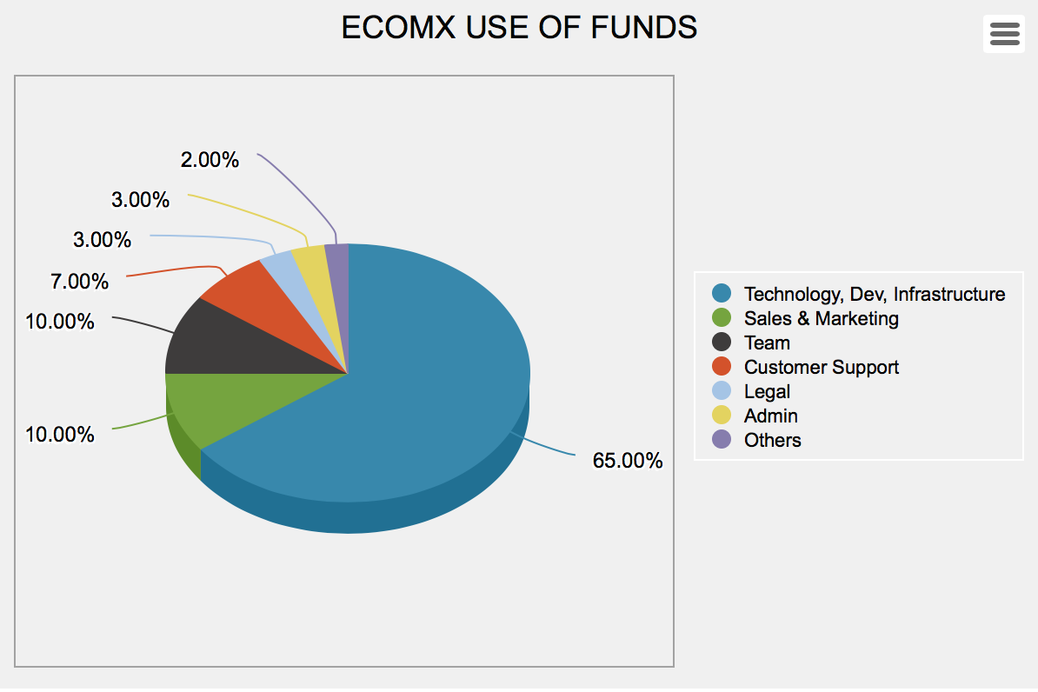

### TECHNOLOGY, SOFTWARE DEVELOPMENT, INFRASTRUCTURE

Refers to the cost of building or acquiring core technology, building and maintaining the eComX blockchain including GAS payment to miners initially in the Ethereum blockchain and later for the eComX blockchain, VM, the eComX token, smart contracts, Dapps, etc. including but not limited to server costs, and development tools, consultants, grants to our EDU partners for specific R&D Projects, and Equipment.

### SALES & MARKETING

Refers to the cost of communicating and delivering the organization’s value to its users and partners, such as general outreach through various channels, public relations, media coverage, community building/management, and advertising. Including Sales and Ambassador’s Team and Consultants.

### TEAM

Refers to the cost of assembling a core of world best scientists, PHD Fellows, Engineers, and blockchain experts to lead and manage the development of the crypto-ecommerce technology.

### CUSTOMER SUPPORT

Refers to the cost of assembling a core of support specialists with deep knowledge of the eComX multiple areas to which the public may need assistance with.

### LEGAL

Refers to the organization’s ongoing legal expenses, due to organization setup, and any and all legal advice.

### ECOMX DAO ADMINISTRATION

Refers to the cost of operating the DAO organization including building rent, consultant fees, depreciation on office equipment, supplies, subscriptions and utilities, as well as managerial compensation.

### OTHERS

Refers to incidental and other miscellaneous expenses which cannot be classified such as travel, lodging, and attending conferences, others.

We invite you to share on the vision of eComX and to join us in the eComX project to create a true transformational platform for the future of eCommerce. We believe that eComX will be at the center of the next eCommerce revolution.

### DECLARATION

**U.S. citizens, and US residents who are not “Accredited Investor” according to Regulation D of the United States Security and Exchange Commission, are excluded from purchasing eComX tokens in all phases of the token distribution!**

**The eComX TGE Sale website requires all Accredited Investors to be certified by a 3rd party service and after such certification is uploaded to our servers and properly reviewed, the sale to such accredited investor can be changed from “ verification” to “verified” and then the accredited investor can participate in the token distribution as stated in the eComX token sale “**[**Terms & Conditions**](https://www.ecomx.org/Documents.html)**”.**

**It is important to re-state that the eComX tokens themselves are not securities, commodities, swaps on either securities or commodities, or similar financial instruments. The eComX Tokens are not designed for investment or speculative purposes and should not be considered as a type of investment. Nevertheless, U.S. citizens, residents and non-accredited investors or entities should not purchase or attempt to purchase eComX Tokens.**

**eComX developers has gone through great care to design the TGE software to keep individual US Citizens and other unauthorized persons from purchasing EComX Tokens and to require accredited investors to get verified by our partner: EarlyIQ (** [**https://www.earlyiq.com**](https://www.earlyiq.com) **) and to pass a comprehensive KYC / AML verification managed by our KYC Partner: IdentityMindGlobal (** [**https://identitymindglobal.com**](https://identitymindglobal.com) **).**

**The eComX token distribution contract, the eComX token smart contract, the eComX blockchain, the eComX.org web site and its cross-border crypto-marketplace www.eComX.world are being provided on an “as is” and “as available” basis without representations, warranties, promises or guarantees whatsoever of any kind made by eComX. Prior to purchasing eComX tokens, you should ensure that you carry out your own examination and investigation and carefully review in the entirety the risks associated with purchasing eComX tokens as set forth in the eComX tokens Sale Terms & Conditions document. Purchases of eComX tokens are non-refundable and purchases cannot be cancelled. Under no circumstances will you be entitled to receive money or compensation for any eComX Token purchased or your inability to purchase eComX tokens. The eComX tokens do not have any other rights, uses, purpose, attributes, functionalities or features, express or implied beyond those specified in this document and whitepaper.**